NSS Small Grant Scheme for Bird
Conservation Research
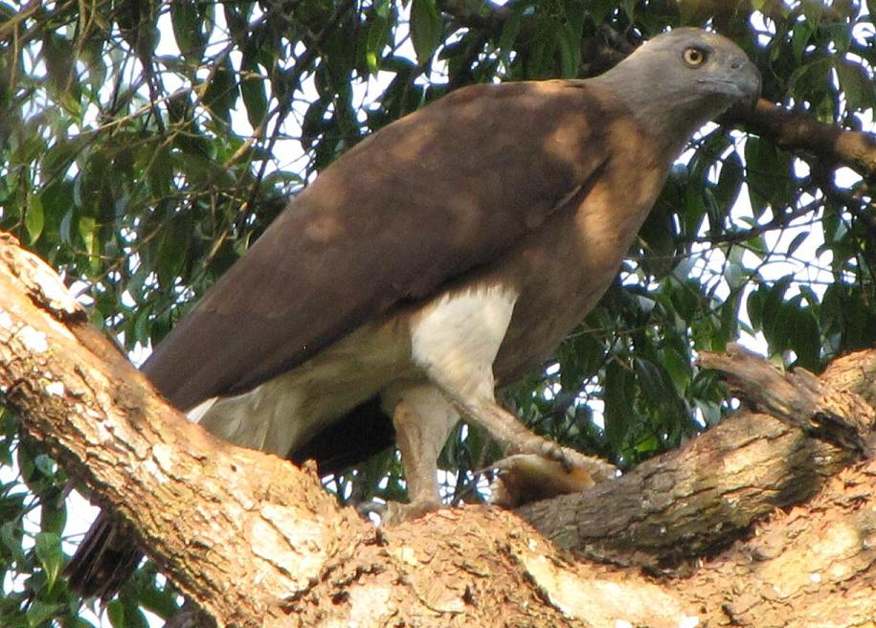 | 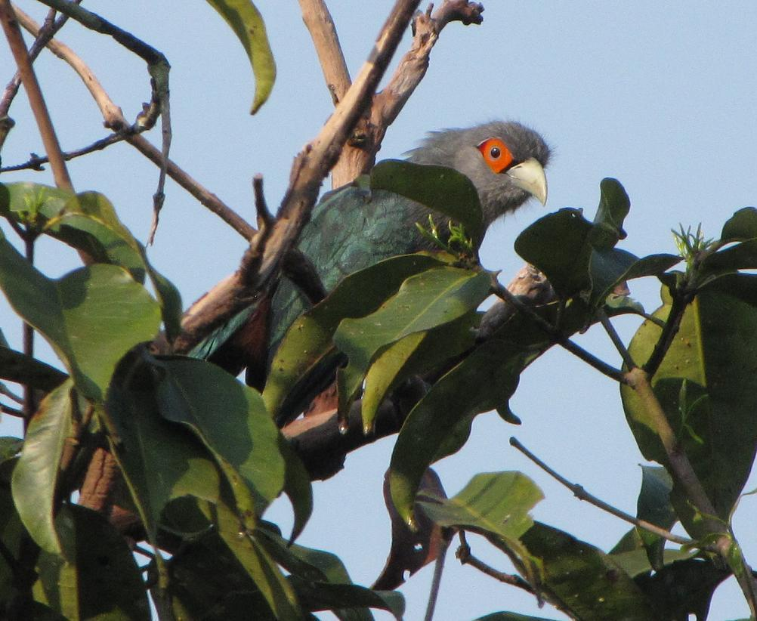
Two examples of threatened forest birds in Singapore, the Grey-headed fish-eagle and the Chestnut-bellied Malkoha (Yong Ding Li)

Singapore is home to over 180 resident bird species, a respectable total considering our modest land area of slightly over 700 sq km. Located in the heart of Sundaic Southeast Asia which was formerly covered entirely in forest, Singapore’s own forests are no doubt an important bird habitat supporting rich numbers of resident birds. More species of birds are found in forests than any other habitats. These include communities of babblers, bulbuls and woodpeckers. Other important habitats here include secondary scrub, abandoned plantations, freshwater marshland, mangroves and grasslands. In Singapore, secondary scrub is still extensive and may support some bird species that are usually found in forests (e.g. Rufous woodpecker).

Habitat destruction due to the rapid pace of Singapore’s urban development has led to the loss of over 95% of our original forests and mangroves. This has also resulted in the creation of secondary habitats such as scrub and old plantations which support few bird species, especially adaptable ones. As a result, many of our forest and mangrove birds are now extinct, while a great number are imperilled. Singapore’s Red Data Book lists over 50 species that are critically-endangered, endangered or vulnerable. This comprises an alarming 30% of extant species. Examples of birds with such worrying statuses include our largest woodpecker, the White-bellied Woodpecker, which was last seen in 2004 and may now be extinct. Another example is the Great-billed Heron, a massive heron that persists precariously on islets south of the mainland which are under pressure from development.

Despite the presence of extensive research facilities in Singapore (e.g. bird collections, libraries and labs), it is surprising that minimal research work has been carried out on our threatened bird species. Existing research work tends to concentrate on the overall avifauna situation, highlighting general threats to our resident birds, but fail to address conservation and ecological concerns of individual species or groups of species. Furthermore, there are no long-term scientific studies of population patterns of most of our threatened species. We continue to speculate how these species are faring, based on observations sent by birdwatchers. Furthermore, we lack reliable population information even for our commonest raptors like the Brahminy Kite and White-bellied Fish Eagle.

The Nature Society (Singapore)’s Bird Group is introducing the “Small Grant Scheme for Bird Conservation Research” to address the paucity of local ornithological research, and to complement our existing annual censuses of Singapore’s avifauna. Its key objective is to encourage and provide financial support for bird field research in Singapore, with an emphasis on locally threatened species. Research work may include extensive field surveys, population counts and mapping, followed by statistical analysis. Field research will be integral to bird conservation by generating recent data of local species that are currently at stake so as to support future conservation measures. This scheme will provide funding of up to S$2000 to cover transport costs, logistics, purchase of research equipment and software during the course of research work. Interested applicants are encouraged to fill in the form below and submit it to Yong Ding Li at zoothera@yahoo.com

Bird Studies in Singapore

Small Grants Application Form

Nature Society (Singapore) Bird Group
510 Geylang Road, #02-05, The Sunflower, Singapore 389466
Please complete this form and email it to: Yong Ding Li at zoothera@yahoo.com

The completed application form and one referee letter must be attached before it is considered for review by the NSSBG research committee.
1 | - Title of proposed project:
2 | - Name of applicant:  Organisation (if applicable):
3 | Contact details  Address:  Telephone:  Email:  Website:
4 | - Amount of funding you are applying for (maximum SGD 2000)
5 | Executive summary  Please summarise in 100 words the overall aim(s) of your project as set out in this application.
6 | Personal summary (you may want to attach this section separately)  - Nationality  - Age  - Education  - Description of past work  - Description of current work  - Long term plans for the future  - Research experience (if any)  - Selected publications
7 | Your research objectives  i. Briefly provide some background information of your work in no more than 200 words. (you may want to cover past research conducted on the subject, current studies and knowledge gaps)  ii. Briefly explain why your study is important to bird conservation in Singapore in no more than 200 words.  iii. Please list all the major activities planned for your project and their detailed methodology, along with an approximate timeline for the project. Explain exactly the procedures you have planned and why it is necessary for your project.
8 | Your team and potential collaborators (if any)  Please describe who your partners/collaborators are in this project and the experiences and knowledge they will contribute to your project.
9 | Financial information  Please provide an itemised budget for the specifics of the project you are applying for, showing what funding you have already secured and stating what else you are requiring funds for. All figures should be stated in Singapore dollars (SGD). Please also state how you plan to follow-up upon conclusion of this project and how it would be funded thereafter.
10 | Declaration  The information submitted in this application form is accurate to the best of my knowledge. Should any significant developments arise after this application has been made, I shall immediately notify the Nature Society (Singapore) Bird Group. I consent to the publication of information contained within this application form and the contents of my research on the website of the NSSBG and its publications.  Signature: _____________________  Date: _________________________

