The Common Iora and His Relatives

By Yong Ding Li

In this issue of the new series of Singapore Avifauna, the Common Iora Aegithinia tiphia singaporensis, chosen logo of the Nature Society’s Bird Group and possibly the only bird taxa endemic to Singapore is featured, together with its 3 similarly looking cousins throughout the Oriental Region. This characterful, perky and well-marked little bird definitely is the favoured choice here for quite a few reasons. Apart from its distinct colour scheme of stark black and fiery yellow that is NOT easily forgettable, the resilient Common Iora is also a very highly successful species, being able to live in very close proximity to Man. In the cool hours of the morning or evenings, its loud piercing whistles emanate from neighbourhood parks, forest parks, roadside trees, wastelands, backyards and sometimes even the car parks of HDB estates. It is no wonder this bird carry some symbolic significance as well as identity here and would have been a very suitable candidate as National bird as opposed to the incumbent Crimson Sunbird!

Introducing the Iora Family - Aegithinidae

As much as the Common Iora holds significance for Singapore natural history (may be the only endemic ‘bird form’), the family of Ioras also hold significance as far as the larger Oriental region is concerned. (In natural history context, the Oriental region is a geographical region drawn by biogeographers to define the fauna bounded by South China in the North, Pakistan in the west and the Moluccas as the eastern limit). Among the Oriental region’s other endemic passerine groups of leafbirds, bluebirds, rhabdornises and others, the Ioras constitutes very small family of 4 similar looking yellow-hued species widespread throughout almost the entire Oriental region and is closely allied to the monarches (Tribe Monarchini), drongoes (Tribe Dicrurini) and philentomas, woodshrikes, vangas etc (Subfamily Malaconotinae, Tribe Vangini) in the enlarged parvorder Corvida (Crows and allies). Older field guides following now outdated morphology-based taxonomies tended to group the Ioras with the superficially similar leafbirds-fairy bluebirds, babblers, warblers and sometimes even bulbuls. Recent DNA-DNA hybridisation studies and nuclear DNA base-sequence analysis have proved these taxonomies to be invalid, highlighting some of the confusions brought about by the effects of convergent evolution in species.

Almost all the countries within the Oriental region own at least one species of Iora, with the appropriately named Common Iora being the most widespread and abundant. Birdwatchers travelling through Malaysia, Thailand and Indonesia have access to the greatest varieties of Ioras, with the Green and Great Ioras, both forest species and the Common Iora, an open country-mangrove species present. Towards the dryer western fringes of the Orient, the Common Iora disappears, only to be replaced by the sometimes sympatric and paler Marshall’s Iora. Very close similarities in appearances between the Common and Marshall’s Ioras show that the latter may have only recently diverged from the original Common Iora lineages. Dry acacia scrub and deciduous forests of continental India in Rajasthan, Gujarat, Uttar Pradesh and other northwestern parts of India form the natural habitat of Marshall’s Iora, also sometimes known as the White-tailed Iora. Meanwhile, its highly adaptable congener, the Common Iora possesses the largest range of the group. Its vast range stretches from the Indian Terai towards Southernmost China in Yunnan province and finally eastwards towards Borneo, Java and Palawan, with the whole of continental South-East Asia within its range though strangely it does not cross Wallace’s line into Sulawesi and beyond. At least ten distinct races are known to be present for Common Iora.

The two other remaining Ioras have ranges considerably smaller than its aforementioned widespread cousin. For example, Green Iora is a Sunda endemic, largely confined to the lowland and hill forests of the Thai-Malay Peninsula and the Greater Sunda Islands. Last of the family and biggest of them all, the forest-loving Great Iora has a slightly bigger home range, occupying almost all of continental South-East Asia and slipping over a little into China’s southern tip of Xishuangbanna region in Yunnan province.

Being birds of the plentiful tropics, all the Iora species are sedentary, in other words, non-migratory and can be encountered all year round in suitable habitats

Iora Nomenclature, Races and Geographical Ranges

Range maps of the 4 Iora species
1
2
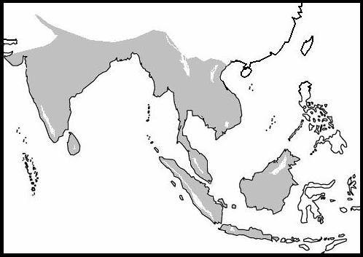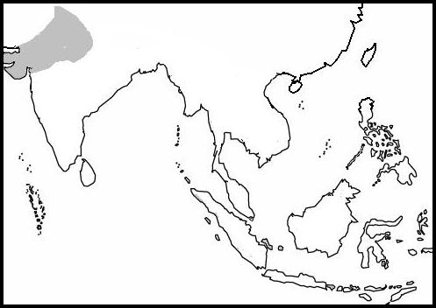
4
3
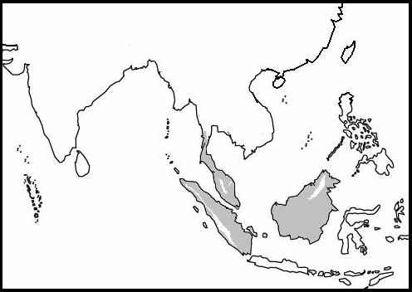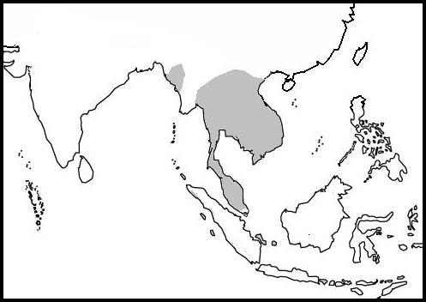

- (Top Left) Common Iora
- (Top Right) Marshall’s Iora
- (Bottom Left) Green Iora
- (Bottom Right) Great Iora

Nomenclature and Subspecies of the Iora members

Common Iora Aegithinia tiphia (Linnaeus, 1758)
Other names: Shaubeegi (Hindi), Sinna mampala-kuruvi (Tamil), Burung Kunyit Kecil (Malay), hēi-chì què-bēi (Chinese), Chim nghệ ngực vàng (Vietnamese), hime konoha-dori (Japanese), Schwarzflügel-Aegithina (German), Petit Iora (French)

1. A. t. aequinimis Palawan, (Philippines), North Borneo (East Malaysia)
2. A. t. cambodiana Indochina (South Vietnam, Cambodia, Thailand)
3. A. t. deignani North Myanmar (May be an intergrade)
4. A. t. djungkulanensis Ujong Kulon, West Java (Indonesia) (Now invalid)
5. A. t. horizoptera Southern Myanmar, Thailand and Peninsular Malaysia, Sumatra
6. A. t. humei Central India
7. A. t. multicolor South India and Sri Lanka
8. A. t. philipi Northern Indochina (Vietnam, Laos, Myanmar), South China
9. A. t. septentrionalis Northwest India
10. A. t. singaporensis Singapore (mostly lumped with horizoptera)
11. A. t. scapularis Java, Bali (Indonesia)
12. A. t. tiphia North – Northeast India, Myanmar
13. A. t. trudiae Brunei Bay islands (Brunei) (Now Invalid)
14. A. t. viridis South and Central Borneo (Indonesia, Brunei, East Malaysia)

Marshall’s Iora Aegithinia nigrolutea (Marshall, 1876) – Monotypic
Other names: Shaubeegi/Shaubeega (Hindi), Fatik-jal (Bengali), Schwarzkappen-Aegithina (German), Iora à queue blanche (French)

1. A. nigrolutea Northwest India and small parts of Pakistan.

Green Iora Aegithinia viridissima (Bonaparte, 1850) ~ Near-threatened/Lower risk
Other names: Burung Kunyit Hijau (Malay), lǜ què-bēi (Chinese), midori hime konoha-dori (Japanese), Smaragd-Aegithina (German), Iora émeraude (French)

1. A. v. thapsina Anambas islands (Indonesia) Natunas islands and Tioman?
2. A. v. viridisssima Southern Myanmar, Thailand, Peninsular Malaysia and Greater Sunda Islands (Indonesia, Brunei, East Malaysia)

Great Iora Aegithinia lafresnayei (Hartlaub, 1844)
Other names: Burung Kunyit Rimba (Malay), dà lǜ què-bēi (Chinese), Chim nghệ lớn (Vietnamese), ō hime konoha-dori (Japanese), Langschnabel-Aegithina (German), Iora de Lafresnaye (French)

1. A. l. innotata Rest of Continental South-East Asia (Thailand, Laos etc)
2. A. l. lafresnayei South Thailand, Peninsular Malaysia
3. A. l. xanthotis Cambodia and South Vietnam. (May be an intergrade)

General Impressions and Morphology

Ioras are a distinctive bunch, with their fiery combinations of yellows, greens and blacks and at any rate, rather compactly built birds. The Common Iora, for example, which for many birdwatchers is the first glimpse into the Iora subfamily, averages the size of a Eurasian Tree Sparrow, hovering at around 12 – 14.5 cm. Its overall built is robust and stout-billed, reminding of the close affinities shared with the Crows like the allied drongoes, bluebirds among others while the Great Iora being the largest member also possesses the longest bill by proportion.

Sexual dimorphism occurs but varies throughout the Ioras; differences between the males and the females of all the members are sometimes not especially clear-cut. For the Common Iora, this is complicated by the existence of numerous races throughout South-East Asia, though many of the races harbour only very subtle differences in their appearances. The Singapore and Peninsula races singaporensis and horizoptera, while geographically distinct only exhibit very minute differences, so much so that the former is often lumped with the latter, much to the chagrin of local birders. Males of most Common Iora races in their breeding plumages are the most spectacular and vividly coloured among the Ioras, having nearly jet-black upperparts, only to be marginally broken by one to two conspicuous white wingbars and sometimes a pale green to white rump region. Otherwise, the black ‘coat’ worn extends continuously from the loral regions to the mantle, wings and eventually the tail though some of the other races elsewhere in South-East Asia may possess darkish green to pale green mantles. Females of Common Ioras are noticeably more drab compared to the males and are probably often confused with the very similarly plumaged non-breeding Males. Most of the female Common Iora races are less strikingly marked than the males, lacking black in their upperparts and this is instead replaced by shades of darker olive green even though the overall bird is still dominated by yellow hues. Conspicuous also is a thin yellow complete eyering.

For the other members of the Iora subfamily, their overall appearances are basically variations upon a theme. Morphologically, Marshall’s Iora is most similar to Common Iora, followed by Green Iora, which is familiar to many of us as among the commonest forest birds in Panti Forest Reserve. Overall ‘colour scheme’ of the Marshall’s Iora is pretty much the same like others except for the white rim to the tail feathers and also a patch of yellow on the mantle-nape region. Green Iora whereas, has a stark shade of green extending all over the head to the mantle and breast, including the lores, which are yellow in the similar Common Iora. Another feature that sets Green and Common apart is the colour of the wingbars, yellow in Green (for females only) and white in Common (both sexes) and this is quite a useful fieldmark, especially when it comes to separating the very similar looking female Common Ioras and female Green Ioras where they ecologically overlap at forest edges. Last but not least, our considerably bigger Great Iora here is easily also the biggest member of the group and not as strongly marked as its lesser kin, containing the typical Iora’s yellow overalls and also a nearly black upperparts for males. Unlike the other 3 Ioras, the Great lacks any conspicuous wing bars except in the females.

Ecology and Behaviour

Watching the antiques of Ioras as they work is always pleasurable and interesting, not just because of the bright colours, but also due to their active behaviour and pleasant calls. Take a walk in many parks and gardens here in Singapore in the mornings and one is able to indulge in the varied and sweet chorus of the Common Iora, especially when a resident pair is present. These birds keep in constant contact as they sometime forage separately, by means of cacophonies of sweet, drawn yet powerful musical whistles and also a variety of varied chirrups and chatters.

In Singapore, the Common Iora is among the few successful birds species that has managed to adapt to a largely built-up environment and hence spread widely, from its original habitats of back mangrove vegetation and scrub into gardens, parks and even roadside verges along busy roadways. Next time, do not be surprised to see a pair of Ioras out and hopping about on that roadside Yellow Flame tree when you are waiting for buses. Likewise, throughout the rest of South-East Asia, Common Ioras are doing very well and has been known to occupy plantations, secondary forests and sometimes on rare occasions even dense swamp forests. Green Ioras, unlike their cousins the Common, are more or less largely confined to forested areas, favouring canopies of dense evergreen forests, though on rare occasions has also been known to stray into mangrove forests. Any person who has paid visits to places like say, Panti or Taman Negara would be able to encounter flocks of Green Iora moving through the high treetops at very high encounter rates. As one heads further North up the Peninsula towards Thailand and the rest of continental South-East Asia, Green Ioras become a less conspicuous element of the Avifauna and are ecologically replaced by the big brother of the tribe, the Great Iora in both lowland and hilly forests, finally disappearing altogether somewhere along the Thailand and Tenasserim (Myanmar) portions of the Peninsula. Not surprisingly, some habitat overlap between the two species occurs throughout much of Peninsula Malaysia and parts of Southernmost Thailand. Meanwhile, thousands of miles away in the dry countries and scrubs of Rajasthan in North India, Marshall’s Iora is the main Iora species, often replacing its widespread congener the Common Iora in most suitable habitats.

Ioras generally are active feeders and always on the move to find small arthropod prey (e.g. beetles, caterpillars, spiders). Observing this aspect of their behaviour is always amusing. Birds hop and jump about like little yellow clowns, from twig to twig, gleaning off hidden insect prey beneath leaves and twigs. When a prey, say a caterpillar is spotted, the Iora gleefully hops towards it and sometimes even try to reach it from unusual angles and positions, especially when the quarry is well concealed or too ‘off the beaten twig’. While most times, only a pair of Ioras can be observed hunting, some of the Iora species also participate in mixed flocks during their foraging endeavours to improve chances of flushing and encountering prey.

One species often seen in company of fellow insectivores would be the gregarious little Green Iora. In Panti, Groups of 4-6 individuals, sometimes more Green Ioras forage alongside Scarlet Minivet, Large Woodshrike, Black-winged Flycatcher-Shrike, Lesser Cuckooshrike, Velvet-fronted Nuthatch, Buff-rumped Woodpeckers and Blue-winged Leafbirds. Further north in Kaeng Krachan, Cat Tien National Parks and Doi Chiang Dao, I have also encountered pairs of Great Iora involved in very large mixed foraging flocks, together with noisy parties of Greater Racket-tailed Drongo, Black-hooded Oriole, Large Woodshrike, Velvet-fronted Nuthatch, Black-naped Monarch, Heart-spotted Woodpeckers, Black-and-Buff Woodpecker, Blue-winged Leafbirds, Brown-cheeked Fulvetta and Sultan Tit. Even our humble neighbourhood park and often-sedentary Common Iora can occasionally be seen with various other insectivorous species in such feeding flocks. Feeding colleagues in the HDB car parks have been noted to include Sunda Pygmy Woodpeckers, Arctic Warblers, Olive-backed Sunbirds and occasional Flyeaters.

Courtship and Nesting

The months ranging from January to June-July are busy periods of countless chores for breeding parents actively raising a brood. Most of the Iora species are recorded to actively nest during these few months though Marshall’s Iora have been known to nest till as late as August. The typical Iora’s nest, which contains about 2-4 pale coloured eggs, is a neat little cup lined with dried fibres/cobwebs and situated a few metres above the ground on the fork of tree branches like some of the monarch flycatchers. Both parents actively participate in feeding duties after the eggs hatched and this dual effort may unfortunately, sometimes expose the chicks to nest predators like Crows and Orioles.

Among the Ioras, the Common Iora, which naturally is the most often observed species, has a rather fla mboyant courtship display. During the breeding seasons, the plumage of male Common Ioras is particularly bright and contrasting. In an attempt to win over the attention and breeding rights of the potential female, the male engages himself in some aerial acrobats. With most feathers, especially those from the rump fluffed out, the male escalates into the air and than eventually parachutes down towards where he was perching initially, to the by now ‘astonishment’ of his would-be mate. He then cocks up his tail, peacock style and droops his wings, all this gestures executed amidst considerable musical accompaniment of sibilant churrs, haughty whistles and chirrups.

Threats and Conservation

All the Iora species are common and widespread and have therefore not been assessed under any threat categories with the exception of the Green Iora. Green Ioras, being strictly forest birds are vulnerable to the threat of deforestation in the long-term future in its native home range throughout insular Southeast Asia. Deforestation, either legal or illegal for timber extraction, monoculture and urban development has annihilated nearly all of the remaining primary lowland forests of the Sundas and this means that Green Ioras may potentially lose all their homes if logging is allowed to continue unabated. Fortunately, the species is adaptable to a certain degree and has been found to persist well in degraded secondary lowland forests, so it remains out of the ‘threatened’ range for the time being. Presently, the Green Iora’s status, based on Birdlife International criteria is ‘near-threatened/lower risk’ while all other Ioras are ‘least concern/lower risk’.

Where to see them – Localities throughout the Orient

The following is a modest list of places, mostly protected parks where one has a very high chance of observing the respective Iora species. Ioras are not confined therein and can be found in other places with suitable habitat, whether protected or not.

Common Iora Sungei Buloh Nature Reserve, Bukit Timah Nature Reserve, Bukit Batok Nature Park, Pasir Ris Park, Singapore Botanical Gardens, Central Catchment Forests (all Singapore) and most parks and gardens throughout Southeast Asia.

Green Iora Panti Forest Reserve, Ampang Recreational Forest (Taman Rimba Ampang), Taman Negara National Park (West Malaysia), Danum Valley Conservation Area, Tabin Wildlife Reserve, Gunung Mulu National Park, Sepilok Rehabilitation Centre (East Malaysia, Borneo), Way Kambas National Park, Gunung Leuser National Park (Sumatra, Indonesia), Gunung Palung Nature Reserve, Sungai Wain Protection Forest (Kalimantan, Indonesia), Ulu Temburong National Park (Brunei)

Great Iora Doi Chiang Dao Wildlife Sanctuary, Doi Inthanon National Park, Kaeng Krachan National Park, Khao Yai National Park (All Thailand), Taman Negara National Park, Ayer Keroh Recreational Forest (West Malaysia), Nam Cat Tien National Park, Tam Dao National Park, Cuc Phuong National Park (all Vietnam)

Marshall’s Iora Keoladeo Ghana Bird Sanctuary, Sariska Tiger Reserve, Ranthambore National Park, Gir National Park (All India).

Selected References

- Ali, S. (2002). The Book of Indian Birds. 13th Edition Revised. Oxford University Press, Bombay Natural History Society.

- Castelletta, M., Sodhi, N.S. & Subaraj, R. (2000). Heavy Extinctions of Forest Avifauna in Singapore: Lessons for Biodiversity Conservation in Southeast Asia. Conservation Biology Vol.14, No.6: pp 1870 – 1880.

- Jeyarajasingham, A. & Pearson, A. (1999). A Field Guide to the Birds of West Malaysia and Singapore. Oxford University Press.

- Kennedy, R.S., Gonzales, P.C., Dickinson, E.C., Miranda, H.C. & Fisher, T.H. (2000). A Guide to the Birds of the Philippines. Oxford University Press.

- Lekagul, B. & Round, P.D. (1991). A Guide to the Birds of Thailand. Saha Karn Bhaet Co. Ltd.

- Lim, K.S. & Gardner, D. (1997). Birds. An Illustrated Field Guide to the Birds of Singapore. Sun Tree Publishing Ltd.

- Mackinnon, J. & Phillipps, K. (1993). A Field Guide to the Birds of Borneo, Sumatra, Java and Bali. Oxford University Press.

- MacKinnon, J. & Phillipps, K. (2000). A Field Guide to the Birds of China. Oxford University Press.

- Robson, C. (2000). A Field Guide to the Birds of South-East Asia. New Holland Publishers.

- Wells, D.R., Dickinson, E.C. & Dekker, R.W.R.J. (2003). Systematic Notes on Asian Birds 34. A Preliminary Review of the Aegithinidae. Zoologische Verhandelingen Leiden 344, 12-ix.2003: pp 7-15.

.

